**MAD 6360**

**Assignment 1 - Git and GitHub**

**Krithika Reddy Cherukupally [002831440]**

1. Version control and Git training in LinkedIn Learning certification.



1. Git Branching

a) Main – Introduction Sequence

b) Remotes – Push & Pull -- Git Remotes!

1. Visualizing Git

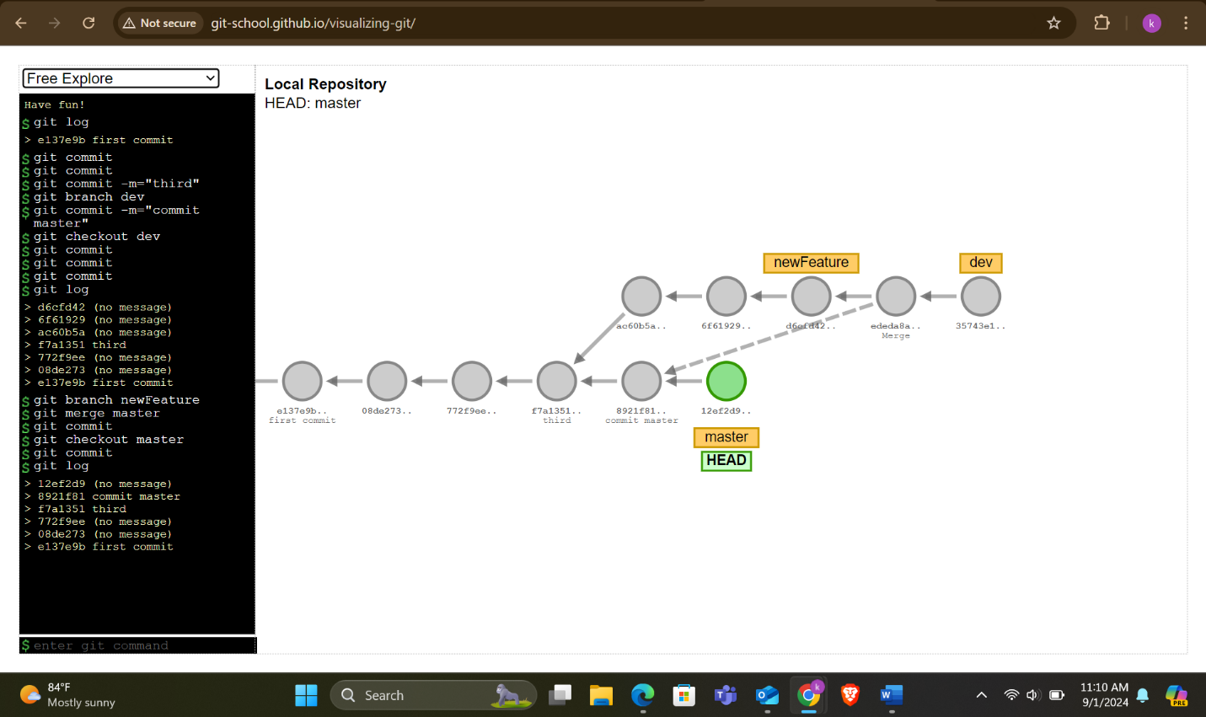

1. A git ignore file is a simple text file used in Git to tell it which files and folders to ignore and not track in a project. It’s placed in the main folder of the project and has rules to guide Git on what files should not be added or committed.
2. git diff <commit1> <commit2>

Using git diff command, you can find out what new changes have been made or what has been removed, making it easier to review and understand updates before you save them.

1. In Git, HEAD shows the most recent commit on the branch you're working with. It acts as a marker for the branch you're currently using, pointing to the latest commit.
2. git restore <file>

The command git restore <file> takes a file back to the state it was in the last time you saved changes in Git, canceling any recent edits you made. It only changes the file in your current workspace and doesn’t alter any saved history.

1. git revert <commit>

The git revert <commit> command undoes changes from a specific commit by creating a new one that reverses them, keeping the original commit and the undo in the history.

1. GitHub account

<https://github.com/KrithikaReddygsu>